Patient Name____________________________________________ DOB: __/__/_____ Gender: M / F
Address:____________________________________ City:_______________State:____ Zip:________
Preferred Phone:______________________ Email:_______________________@_______________
Receive appointment reminders and quarterly E-Newsletter via E-mail? Yes / No thanks
Preferred Language: ________________
Race: White / African American / Asian / American Indian or Alaska Native / Native Hawaiian / Pacific Islander / Other / Decline to Answer
Ethnicity: Non-Hispanic / Hispanic/Latino / Decline to Answer
Smoking Status: Never Smoked / Every Day Smoker / Occasional Smoker / Former Smoker
Please List any medications you are currently taking:
Medication Name | Dosage and Frequency (i.e. 5 mg once a day, etc.)
O Mark here and list additional medications on the back of the page, if necessary.

Do you have any medication allergies?
Medication Name | Reaction | Onset Date

Emergency Contact:________________________Relationship:________ Phone:_______________
Primary Doctor Name and Location:___________________________________________________
Is your complaint related to an auto or workplace accident? Yes / No
List any surgical procedures and dates:____________________________________________________
List any accidents or traumas and dates:___________________________________________________
List any hospitalizations/major illnesses and dates:___________________________________________
Females only – Are you pregnant? Y / N / Maybe Date of last menstrual period: ___/___/___
Please mark any of the following conditions/symptoms that you now or recently experienced:
O Cancer O Neck Pain O Chest Pains O Lights Bother Eyes
O High Blood Pressure O Pain in Hands or Arms O Shoulder Pain O Dizziness
O Heart Attack O Numbness in Hands or Arms O Shortness of Breath O Loss of Balance
O Stroke O Low Back Pain O Cold Hands/Feet O Loss of Memory
O Diabetes O Pain in Legs or Feet O Fever O Loss of Smell or Taste
O Asthma O Numbness in Legs or Feet O Neck Stiff O Ringing in Ears
O Allergies O Pain between shoulder blades O Sleeping Problems O Tension/Irritability
O Menopause O Joint Swelling O Unexplained Weight Loss O Stomach Upset
O Menstrual Cramps O Jaw/TMJ Problems O Fatigue O Diarrhea
O Depression/Anxiety O Painful Urination O Constipation
O Heartburn/Reflux O Discolored Urine
O Other Medical Conditions_____________________________________________________________________________

Patient Name _____________________________ DOB __/__/____ File# __________
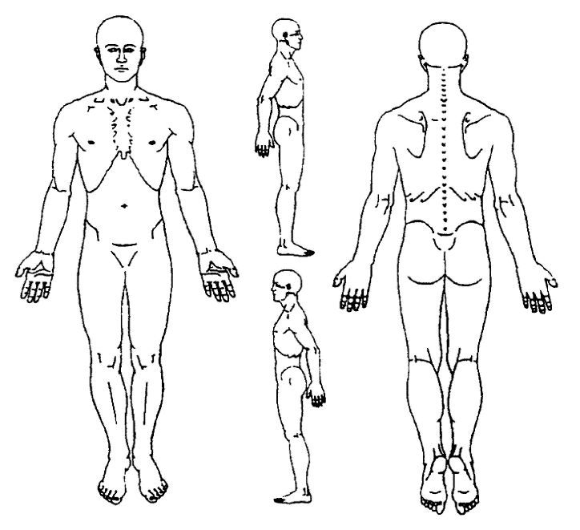
Using the symbols below, mark the area(s) of your complaint:
Dull Ache OOO
Burning XXX
Sharp/Stabbing / / /
Tingling + + +
Numbness = = =
Other ______________ ^ ^ ^

Please Indicate your pain level:
Currently:
(No Pain) 0 1 2 3 4 5 6 7 8 9 10 (Worst Possible Pain)

At worst:
(No Pain) 0 1 2 3 4 5 6 7 8 9 10 (Worst Possible Pain)
Average: (No Pain) 0 1 2 3 4 5 6 7 8 9 10 (Worst Possible Pain)

Release of Information/Authorization
I authorize Ionia Family Chiropractic to release any medical or other information necessary to process insurance claims on my behalf. I also request payment of government or private benefits either to myself or to Ionia Family Chiropractic. This is a permanent authorization that I may revoke at any time by written notice.
Patient Responsibility Statement
I certify that the information I provided is correct and understand it is my responsibility to inform this office of any changes in my health. I understand that I shall be personally financially responsible for all services not paid for by my insurance. I am also responsible for any annual deductibles applicable, copayments, or non-covered services as may be required by my contract with my insurance provider. I agree to allow this office to examine me for further evaluation.

Statement of Disclosure of HIPAA Practices
Your privacy is important to us! We will do everything that we can to ensure your health information is kept secure and private. A copy of our policies and procedures concerning the protection of your health information is available upon request.
I am aware that a copy of Ionia Family Chiropractic’s HIPAA policies and procedures is available on request.

I choose to decline receipt of my clinical summary after visits: (Please ask the front desk for an explanation, if necessary) Agree / No, I'd like my summaries: printed / emailed

______________________________________ ________________ ________________________________________
Patient/Legal Guardian Signature Date Legal Guardian Name

